Green Society Public School
D-
Ratnanagar-7, Sauraha, Chitwan
Annual Examination-2082
Class: Three Time: -2 hrs. F.M.: 50
Sub: Maths
Name: Roll No.: Sec.:
________________ ______________ OBT.MARKS:
INVIGILATOR EXAMINER

​Group 'A' [10 × 1 = 10]

1) Tick (✔) the correct answer.
a) How many millilitres are there in 1 litre?
i) 10ml ii) 1000ml iii) 100ml
​b) The Roman numeral of 51 is:
i) IL ii) XI iii) LI
​c) How many zeroes are there in ten-thousand?
i) 5 ii) 4 iii) 3
​d) The numerator of 8/5 is:
i) 7 ii) 8 iii) 6
​e) Rs 7 is equal to ____ paisa.
i) 700paisa ii) 70paisa iii)7000paisa
​f) What comes after 5692?
i) 5691 ii) 5693 iii) 5694
​g) What comes before 4502?
i) 4500 ii) 4502 iii) 4501
​h) How many angles are there in a circle?
i) 2 ii) 0 iii) 1
​i) How many angles are there in a rectangle?
i) 3 ii) 5 iii) 4
​ j) Descending order means:
i) big to big ii) big to small iii) small to big

​Group 'B' [12 × 2 = 24]
​2) Find the area of the following. (Each unit square = 1 cm²)

Area = _____ cm² Area = _____cm²
​3) Find the perimeter of the followings:
C
N
M
10cm
9cm
10cm
4cm
4cm
B
P
O
A
20cm
10cm
Perimeter =______________________ Perimeter =____________________________
______________________ ____________________________
______________________ ____________________________
4) Convert the following into litre:
a) 13450 ml b) 33025 ml
1000) 13,450(

​5) Arrange the data in ascending order:
6584, 2691, 5105, 3421
______ _______ _______ __________
​6) Expand the following:
24,510 = __________________________________________________________
76,015 = __________________________________________________________
​7) Write odd and even numbers:
69,430 = _____________ 76,546 = _____________
91,071 = _____________ 21,669 = _____________
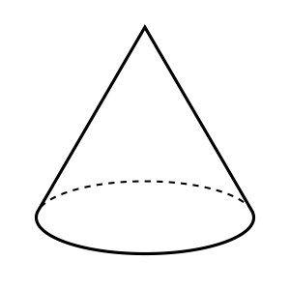
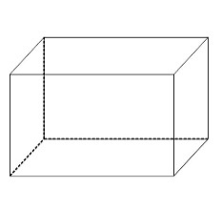
​8) Identify the shapes of the following:

__________________ _________________
​9) Add the following:
5 6 2 9
2 4 7 6
2 4 9 1
6 6 8 0
10) Subtract the following:
6 2 5 2
1 6 7 5
4 5 0 1
2 3 5 1

​11) Multiply the following horizontally:
a) 40 × 50 = _____________ b) 70 × 20 =_______________
​12) Write the Roman numerals of the following:
27 = __________ 55 = __________
61 = __________ 100 = _________
​13) Divide the following:
640 ÷ 5
5) 640 (

​Group 'C' [4 × 4 = 16]
Class | One | Two | Three | Four
No. of students | 20 | 5 | 40 | 35
​14) Draw a bar graph of the following:

15) Multiply the following:
6 1
5 3
4 7
2 4

Rs | Paisa
7 6 | 7 6
2 9 | 5 2
+1 | -1 0 0
Rs | Paisa
8 1 | 2 8
2 3 | 8 5
​16) Add the following (Rupees and Paisa):

​
17) Convert the following into metre (m): (Note: 1 km = 1000 m)
a) 56 km b) 4 km 500 m

The End

